SIMATS ENGINEERING
ASSESSMENT TOOL 2

COURSE NAME: Database Management Systems
COURSE CODE: CSA05
NAME:JAISURIYA D D
REGNO:192421167

COURSE OUTCOME COVERED
CO2: Apply the relational model, relational algebra, SQL query structures, and views to solve database querying and data manipulation problems. (BL3, BL6)
Activity Tool : Scenario-Based Task (High)
Assessment Tool Weightage: 35%
Dr

QUESTIONS Total Marks: 50
Q.No | Question | Bloom's Level | Marks
1 | Given the scenario of a School Management System, identify relations and write SQL to list all students with their class teacher and grade. | BL3 – Apply | 5
2 | A hospital wants to track patient appointments. Design the relational schema and write SQL to find doctors with more than 10 appointments this month. | BL3 – Apply | 5
3 | In an e-commerce scenario, write SQL queries using sub-queries to find products that have never been ordered. | BL3 – Apply | 5
4 | For a university database, write relational algebra expressions to find students enrolled in both 'DBMS' and 'OS' courses. | BL3 – Apply | 5
5 | Given a payroll scenario, create a view showing employees whose salary is below department average and write a query to update their salary by 10%. | BL6 – Create | 5
6 | In a banking scenario, apply JOIN operations to retrieve customer account details, transaction history, and branch information. | BL3 – Apply | 5
7 | A retail store needs daily sales summary. Write SQL with GROUP BY and HAVING to report total sales per category exceeding Rs. 10,000. | BL3 – Apply | 5
8 | For a library system scenario, construct tuple relational calculus expressions to find members who borrowed books from all genres. | BL3 – Apply | 5
9 | Given an inventory management scenario, define CHECK and FOREIGN KEY constraints and demonstrate their enforcement through SQL. | BL3 – Apply | 5
10 | Design a relational schema for an HR system and create materialized views for monthly attendance and performance summaries. | BL6 – Create | 5

Code of Conduct:

I JAISURIYA D D (192421167)certify that this submission is my original work and that I have adhered to the guidelines specified for this assessment.
I understand that any violation of academic integrity rules will result in disciplinary action.

Signature of the student:



RUBRICS FOR CALCULATION:

Scenario based assessment
Criteria | Weightage (%) | Level 4 (Exemplary) | Level 3 (Proficient) | Level 2 (Developing) | Level 1 (Beginning)
Understanding of Scenario | 20% | Demonstrates clear and complete understanding of the scenario and context | Shows good understanding with minor gaps | Partial understanding; misses key aspects | Misinterprets or fails to understand the scenario
Identification of Key Issues | 20% | Accurately identifies all relevant issues and factors involved | Identifies most key issues with minor omissions | Identifies limited issues; some irrelevant points | Unable to identify key issues
Application of Concepts | 25% | Applies appropriate concepts effectively to address the scenario | Applies concepts with minor errors | Limited or partially correct application | Unable to apply relevant concepts
Decision Making | 20% | Makes well-reasoned, logical decisions with strong rationale | Makes reasonable decisions with some justification | Makes weak decisions with limited justification | No clear decisions made or rationale provided
Clarity of Response | 15% | Response is clear, structured, and logically presented | Generally clear with minor issues | Somewhat unclear or poorly structured | Disorganized and difficult to understand

Q1. School Management System
Scenario Understanding
A School Management System maintains information about students, classes, teachers, and grades. The objective is to list all students along with their class teacher and grade.
fa1e837a-330e-40b9-81a5-8bee0f2…
1. Relations
The following relations are required:
Student(Student_ID, Student_Name, Class_ID, Grade)
Class(Class_ID, Class_Name, Teacher_ID)
Teacher(Teacher_ID, Teacher_Name)
Here:
- Student_ID is the primary key of Student.
- Class_ID is the primary key of Class.
- Teacher_ID is the primary key of Teacher.
- Student.Class_ID is a foreign key referencing Class.
- Class.Teacher_ID is a foreign key referencing Teacher.
2. Relationship
Student → Class → Teacher
A student belongs to a class, and each class has a class teacher.
3. SQL Query
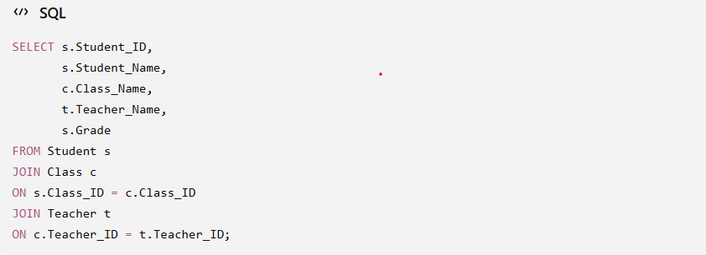

4. Explanation
The first JOIN connects the Student table with the Class table using Class_ID.
The second JOIN connects the Class table with the Teacher table using Teacher_ID.
The SELECT statement displays the student ID, student name, class name, teacher name, and grade.
5. Sample Output
Student ID | Student Name | Class | Teacher | Grade
101 | Arun | 10-A | Kumar | A
102 | Priya | 10-A | Kumar | A+
103 | Rahul | 10-B | Devi | B

6. Conclusion
The proposed SQL query correctly combines the three related relations and provides a complete student report. Using JOIN avoids unnecessary duplication of data and retrieves the required information efficiently.

Q2. Hospital Appointment Management System
Scenario Understanding
A hospital needs a database to manage patients, doctors, and appointments. The objective is to design a relational schema and find doctors who have more than 10 appointments in the current month.
fa1e837a-330e-40b9-81a5-8bee0f2…
1. Relational Schema
Patient(Patient_ID, Patient_Name, Phone)
Doctor(Doctor_ID, Doctor_Name, Specialization)
Appointment(Appointment_ID, Patient_ID, Doctor_ID, Appointment_Date, Appointment_Time)
2. Relationships
Patient → Appointment ← Doctor
- One patient can have multiple appointments.
- One doctor can have multiple appointments.
- Patient_ID and Doctor_ID act as foreign keys in the Appointment table.
3. SQL Query
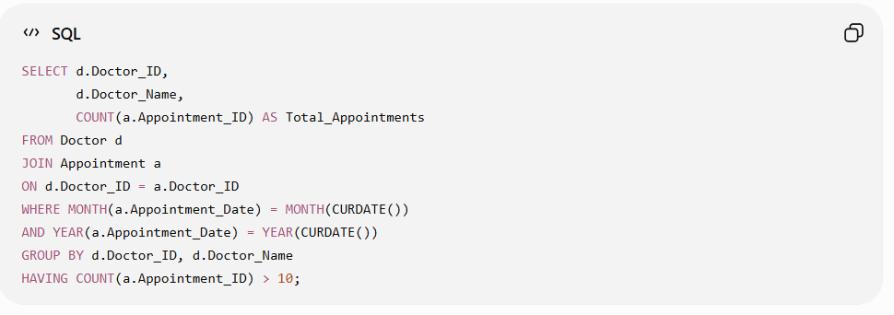
4. Explanation
- JOIN connects doctors with their appointments.
- MONTH() and YEAR() filter appointments belonging to the current month.
- COUNT() calculates the number of appointments for each doctor.
- GROUP BY groups appointments doctor-wise.
- HAVING selects only doctors having more than 10 appointments.
5. Conclusion
The proposed schema properly represents the hospital appointment system. The SQL query efficiently identifies doctors with more than 10 appointments during the current month by using JOIN, WHERE, GROUP BY, COUNT, and HAVING operations.

Q3. E-Commerce Product Management
Scenario Understanding
In an e-commerce system, the database stores information about products and orders. The objective is to identify products that have never been ordered using an SQL sub-query.
fa1e837a-330e-40b9-81a5-8bee0f2…
1. Relational Schema
Product(Product_ID, Product_Name, Price)
Order_Item(Order_ID, Product_ID, Quantity)
The Product_ID in Order_Item refers to the product that was included in an order.
2. Key Issues
- Identify all products available in the system.
- Check whether each product appears in any order.
- Exclude products that have already been ordered.
- Display only products with no order records.

3. SQL Query Using Sub-Query
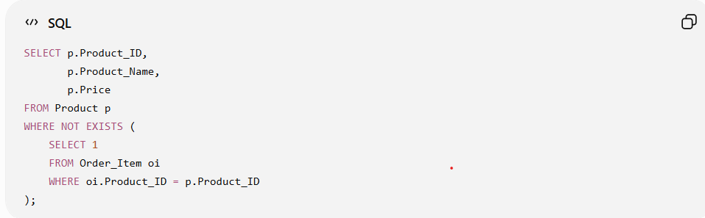
4. Explanation
The outer query selects products from the Product table.
The sub-query checks whether the current product exists in the Order_Item table.
NOT EXISTS returns the product only when no matching order record is found.
Therefore, the query lists products that have never been ordered.
5. Example Output
Product_ID | Product_Name | Price
104 | Wireless Mouse | ₹800
107 | Laptop Stand | ₹1,200
110 | USB Hub | ₹600
6. Conclusion
The NOT EXISTS sub-query is suitable because the requirement is to find products for which no corresponding order exists. It accurately identifies un-ordered products without producing duplicate product records.

Q4. University Database – Relational Algebra
Scenario Understanding
A university database stores information about students, courses, and enrollments. The objective is to find students who are enrolled in both DBMS and OS courses.
fa1e837a-330e-40b9-81a5-8bee0f2…
1. Relations
Student(Student_ID, Student_Name)
Course(Course_ID, Course_Name)
Enrollment(Student_ID, Course_ID)
2. Key Issues
- Identify students enrolled in DBMS.
- Identify students enrolled in OS.
- Compare both student sets.
- Select students appearing in both sets.
3. Relational Algebra
First, find students enrolled in DBMS:
DBMS_Students ← π Student_ID
(σ Course_Name = 'DBMS'
(Enrollment ⋈ Course))
Next, find students enrolled in OS:
OS_Students ← π Student_ID
(σ Course_Name = 'OS'
(Enrollment ⋈ Course))
Finally, find students enrolled in both:
Result ← DBMS_Students ∩ OS_Students
4. Explanation
- σ (Selection) selects the required course.
- π (Projection) retrieves only Student_ID.
- ⋈ (Join) connects Enrollment with Course.
- ∩ (Intersection) finds students common to both DBMS and OS sets.
5. Conclusion
The intersection operation is used because the student must satisfy both conditions—enrolled in DBMS and enrolled in OS. Thus, the final result contains only students who have enrolled in both courses.
Q5. Payroll Management System
Scenario Understanding
A payroll system stores employee salary and department information. The objective is to create a view showing employees whose salary is below their department average and then increase their salary by 10%.
fa1e837a-330e-40b9-81a5-8bee0f2…
1. Relational Schema
Employee(Employee_ID, Employee_Name, Department_ID, Salary)
Department(Department_ID, Department_Name)
2. Key Issues
- Calculate the average salary of each department.
- Identify employees earning below their department average.
- Create a view containing those employees.
- Update the salary of the selected employees by 10%.
3. Create View
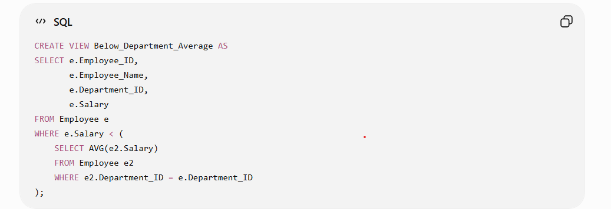
4. Update Salary by 10%
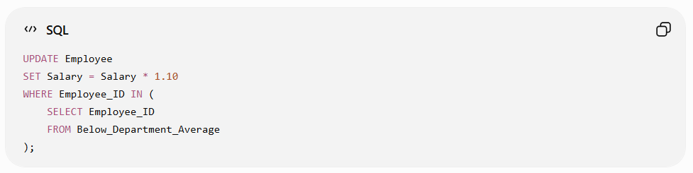5. Explanation
The sub-query calculates the average salary of the employee's department. The WHERE condition selects employees whose salary is below that average.
The view Below_Department_Average stores the selected employee information. The UPDATE statement then increases their salary by 10%.
6. Conclusion
The view provides a reusable way to identify underpaid employees, while the update query applies the required salary increase. The solution uses sub-query, aggregate function, view, and UPDATE concepts appropriately.
Q6. Banking Management System
Scenario Understanding
A banking system stores customer details, account information, transaction history, and branch information. The objective is to use JOIN operations to retrieve complete customer account details, transaction history, and branch information.
fa1e837a-330e-40b9-81a5-8bee0f2…
1. Relational Schema
Customer(Customer_ID, Customer_Name, Phone)
Account(Account_ID, Customer_ID, Branch_ID, Account_Type, Balance)
Transaction(Transaction_ID, Account_ID, Transaction_Date, Transaction_Type, Amount)
Branch(Branch_ID, Branch_Name, Location)
2. Key Issues
- Connect customers with their accounts.
- Connect accounts with transaction records.
- Connect accounts with their respective branches.
- Retrieve all required banking information in a single result.
3. SQL Query
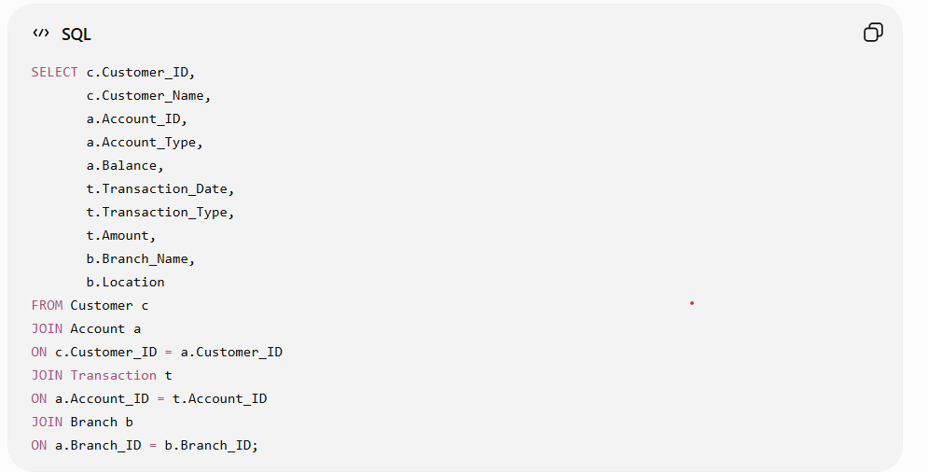
4. Explanation
- The first JOIN connects Customer with Account.
- The second JOIN connects Account with Transaction.
- The third JOIN connects Account with Branch.
- The SELECT statement displays customer, account, transaction, and branch details.
5. Conclusion
Multiple JOIN operations are appropriate because the required information is stored in separate related tables. The query combines these relations and produces a complete banking transaction report.

Q7. Retail Store Sales Summary
Scenario Understanding
A retail store maintains sales records for different products and categories. The objective is to generate a sales summary for each category and display only those categories whose total sales exceed ₹10,000.
fa1e837a-330e-40b9-81a5-8bee0f2…
1. Relational Schema
Category(Category_ID, Category_Name)
Product(Product_ID, Product_Name, Category_ID)
Sale(Sale_ID, Product_ID, Sale_Date, Quantity, Unit_Price)
2. Key Issues
- Identify the category of each product.
- Calculate the total sales for each category.
- Group sales according to category.
- Display only categories with total sales greater than ₹10,000.
3. SQL Query
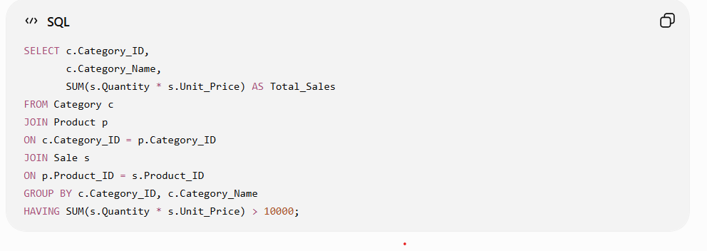
4. Explanation
- JOIN connects the category, product, and sales tables.
- SUM() calculates the total sales amount.
- GROUP BY creates a separate total for each category.
- HAVING filters the groups and displays only categories with sales above ₹10,000.
5. Example Output
Category | Total Sales
Electronics | ₹25,500
Furniture | ₹18,200
Clothing | ₹12,750

6. Conclusion
The query uses JOIN, SUM, GROUP BY, and HAVING to generate the required category-wise sales report. HAVING is used because the condition is applied to the calculated total sales of each category.

Q8. Library Management System
Scenario Understanding
A library system maintains information about members, books, genres, and borrowing records. The objective is to find members who have borrowed books from all genres available in the library.
fa1e837a-330e-40b9-81a5-8bee0f2…
1. Relational Schema
Member(Member_ID, Member_Name)
Book(Book_ID, Title, Genre_ID)
Genre(Genre_ID, Genre_Name)
Borrow(Member_ID, Book_ID, Borrow_Date)
2. Key Issues
- Identify all genres available in the library.
- Identify books belonging to each genre.
- Check the borrowing records of each member.
- Select members who have borrowed at least one book from every genre.
3. Tuple Relational Calculus Expression
{ m | Member(m) AND
∀g (Genre(g) →
∃b ∃br (
Book(b) AND
Borrow(br) AND
b.Genre_ID = g.Genre_ID AND
br.Member_ID = m.Member_ID AND
br.Book_ID = b.Book_ID
)
)
}
4. Explanation
- m represents a member.
- g represents a genre.
- b represents a book.
- br represents a borrowing record.
- ∀ means for every genre.
- ∃ means there exists a matching book and borrowing record.
The expression checks that for every genre, there is at least one book from that genre that the member has borrowed.
5. Conclusion
The universal quantifier (∀) is important because the member must have borrowed books from all genres, not just one or some genres. The tuple relational calculus expression therefore returns only members who satisfy the complete requirement.

Q9. Inventory Management System
Scenario Understanding
An inventory management system stores information about products and their categories. The database must prevent invalid stock values and ensure that every product is associated with a valid category. This can be achieved using CHECK and FOREIGN KEY constraints.
fa1e837a-330e-40b9-81a5-8bee0f2…
1. Relational Schema
Category(Category_ID, Category_Name)
Product(Product_ID, Product_Name, Category_ID, Stock_Quantity)
2. Key Issues
- Stock quantity should not be negative.
- Every product must belong to an existing category.
- Invalid data should be rejected automatically by the database.
- Referential integrity must be maintained.
3. SQL – Creating Tables
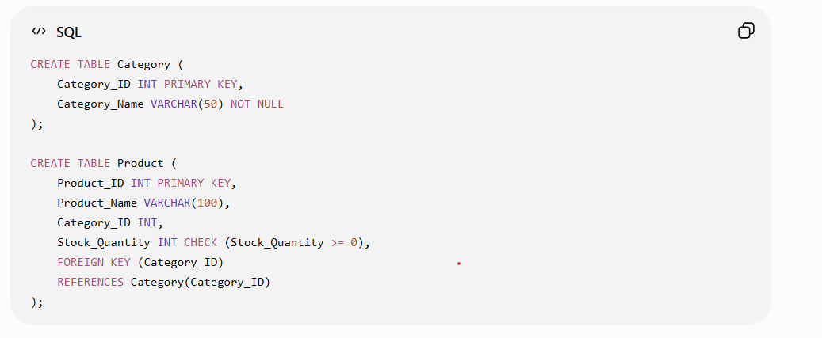

4. Demonstrating Constraints
Valid Data:
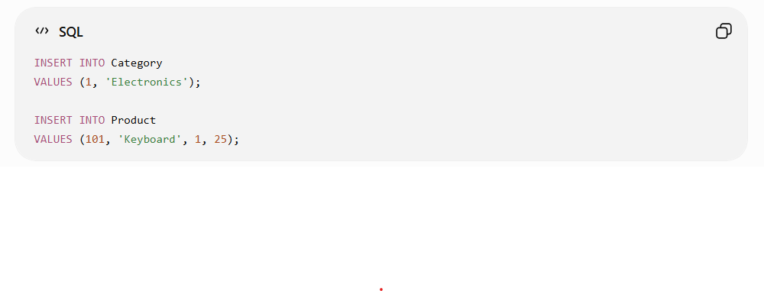CHECK Constraint Violation:
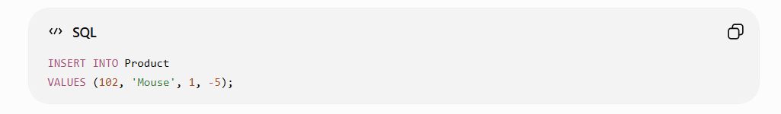FOREIGN KEY Constraint Violation:
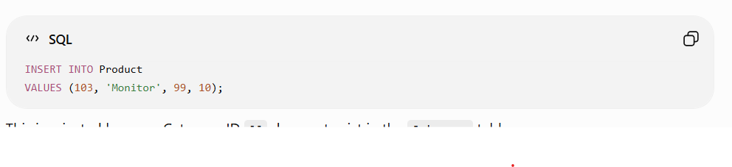This is rejected because Category ID 99 does not exist in the Category table.
5. Explanation
The CHECK constraint ensures that Stock_Quantity is always greater than or equal to zero.
The FOREIGN KEY constraint ensures that Category_ID in the Product table must exist in the Category table.
6. Conclusion
CHECK and FOREIGN KEY constraints maintain data integrity and consistency in the inventory database. They automatically prevent invalid stock values and invalid category references.

Q10. HR Management System
Scenario Understanding
An HR system stores employee, department, attendance, and performance information. The objective is to design a relational schema and create materialized views for monthly attendance and performance summaries.
fa1e837a-330e-40b9-81a5-8bee0f2…
1. Relational Schema
Department(Department_ID, Department_Name)
Employee(Employee_ID, Employee_Name, Department_ID, Join_Date)
Attendance(Attendance_ID, Employee_ID, Attendance_Date, Status)
Performance(Performance_ID, Employee_ID, Review_Date, Rating, Remarks)
2. Key Issues
- Maintain employee and department information separately.
- Record employee attendance by date.
- Store employee performance evaluations.
- Generate monthly attendance summaries.
- Generate monthly performance summaries.
3. Materialized View for Monthly Attendance
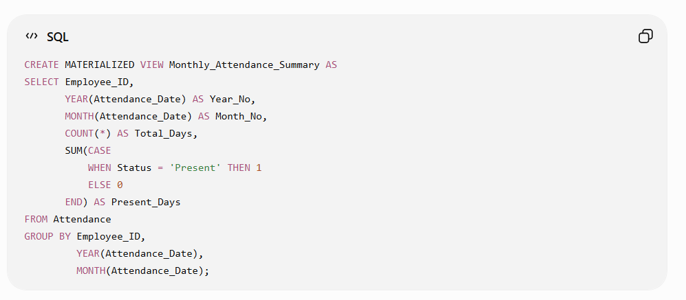

4. Materialized View for Monthly Performance
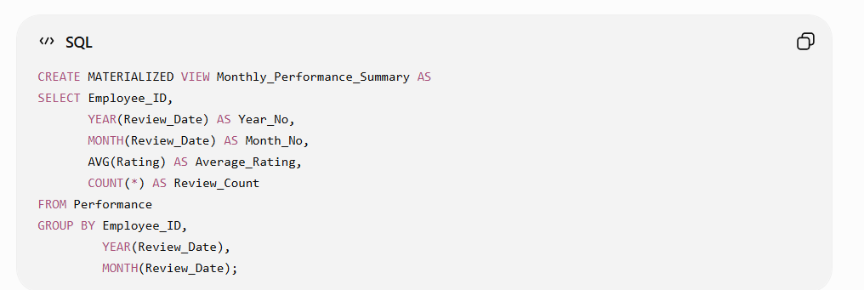5. Explanation
The Monthly Attendance Summary calculates the total attendance records and number of days an employee was present for each month.
The Monthly Performance Summary calculates the employee's average performance rating and number of reviews for each month.
Materialized views store the summarized results, making repeated report generation faster.
6. Conclusion
The proposed HR schema separates employee, attendance, and performance data into related tables. The materialized views provide efficient monthly summaries for attendance and performance, satisfying the requirements of the HR system.

